Small Business Owners Feel Weight of Personal Debt Guarantees
By
Ruth Simon
and
Heather Haddon
| Photographs by Michelle Gustafson for The Wall Street Journal
April 4, 2021 1:07 pm ET WSJ
1x
The vise is tightening on owners of restaurants, fitness centers and other small U.S. businesses trying to hold on until the economy fully reopens. And unlike at most big companies, the burden is often deeply personal.
Townsend Wentz borrowed from his family to open his first Philadelphia fine-dining restaurant in 2014. The chef tapped the equity in his home, erased any semblance of a retirement account and diverted college funds for his daughter into his business. Roughly $1.5 million in personal investment now sits in the balance. The pandemic repeatedly closed his five locations for portions of the year.
On top of that, Mr. Wentz, 53 years old, has a personal guarantee on one location that makes him responsible for around $540,000 in rental payments over five years and an additional $175,000 for a liquor license. The guarantee weighs on Mr. Wentz as he juggles phone bills, tax obligations, rental payments and other expenses.

“It’s like trying to stand in quicksand,” he said. He hopes to have all of his restaurants reopened this month.
Small-business owners taking on debt or signing a lease often end up providing a personal guarantee, in which they promise to be responsible for the payments if the business can’t pay.
Increased vaccination rates, the loosening of state restrictions and the $1.9 trillion stimulus package are raising hopes that these businesses can make it through. At the same time, the weight of those guarantees isn’t dissipating. Many businesses have accrued debt after deferring rent, loan and other payments, and owners worry the stimulus funds will only go so far.
Nearly 60% of small businesses with employees that took out loans used personal guarantees to secure business debt, according to a survey released by the regional Federal Reserve Banks in 2020. Forty-four percent of small firms with employees have more than $100,000 in debt and 8% owe more than $1 million, according to a separate regional Fed survey released this year.
The weight of personal guarantees has grown as the pandemic has stretched on, increasing the amount small-business owners owe and forcing many to draw down savings. Many businesses have had to close and reopen more than once, adding to their costs. A survey completed in late March by the U.S. Census Bureau found that 18% of small businesses said they would need to obtain financial assistance or additional capital in the next six months.
Companies with fewer than 500 employees employed 60.6 million people, or 47.1% of the private-sector workforce, in 2017, according to the Small Business Administration. Applications for new businesses surged last year, according to Census Bureau data, but it isn’t clear how many will actually become businesses and thrive.
The federal Paycheck Protection Program provided $525 billion in forgivable loans to small business last year, and reopened in January with an additional $284 billion in funding. But the program requires businesses to spend at least 60% of funds on payroll to qualify for full forgiveness, limiting the amount of funds available to cover rent and other expenses.
In addition, state and local governments have provided more than $14 billion in grants, forgivable loans and other aid to small businesses to help alleviate the pain, estimates the Institute for Local Self-Reliance, a Minneapolis-based nonprofit that advocates for local economies.
It could take months or even years for small-business owners and their creditors to resolve disputes involving personal guarantees, attorneys and other experts say.
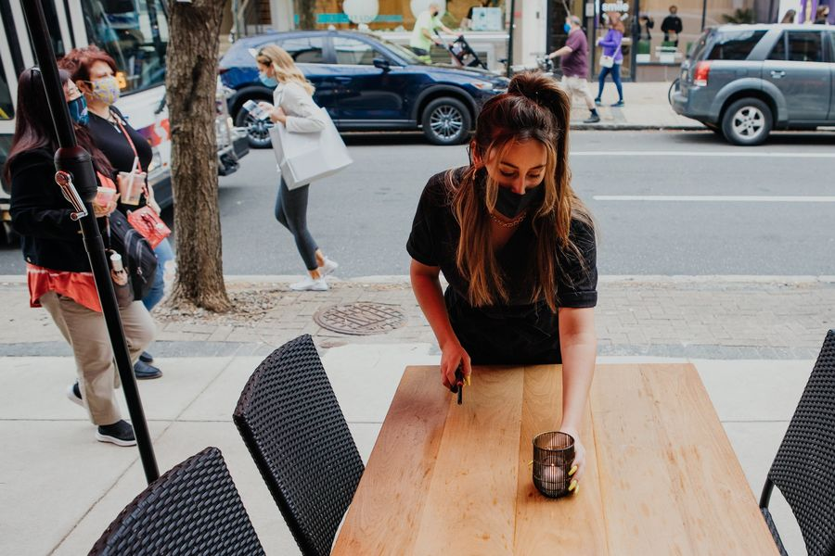
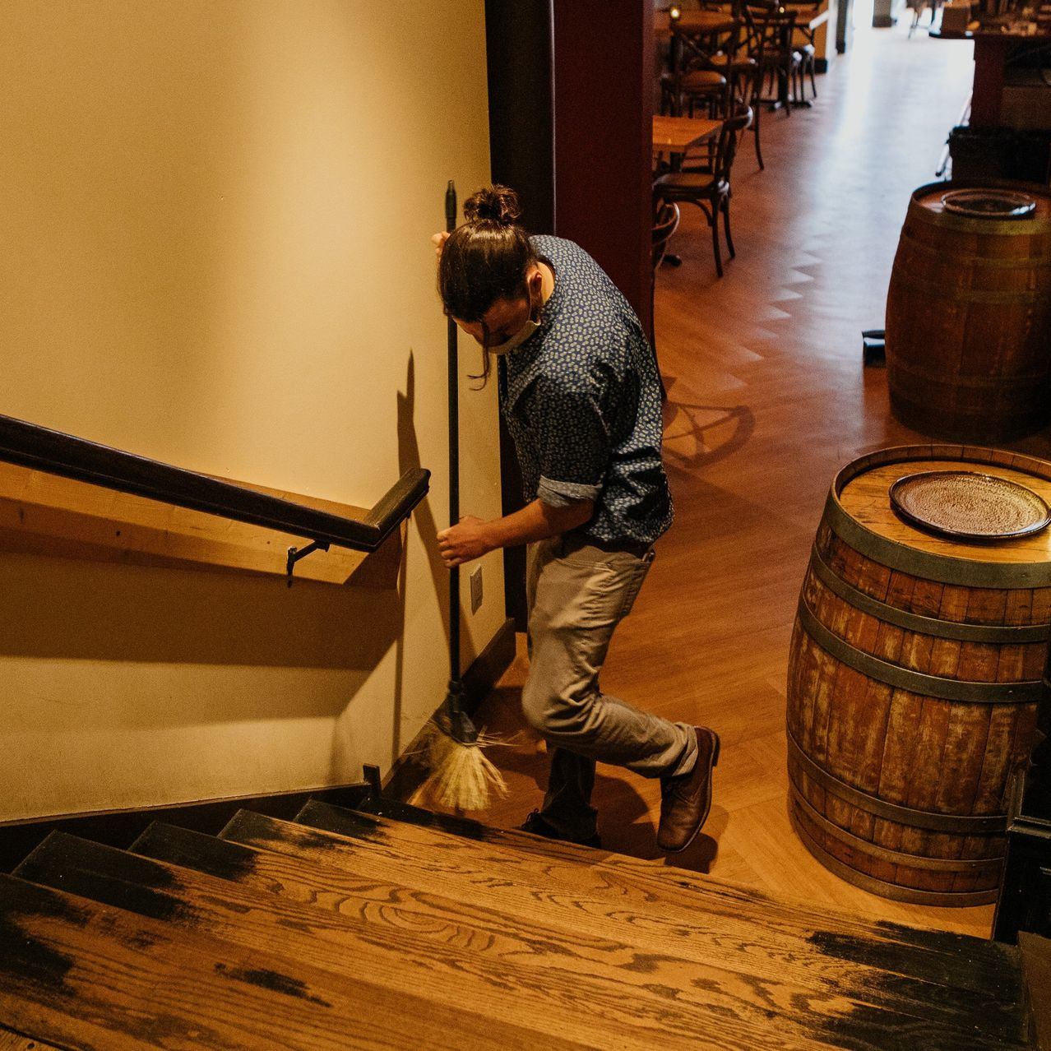
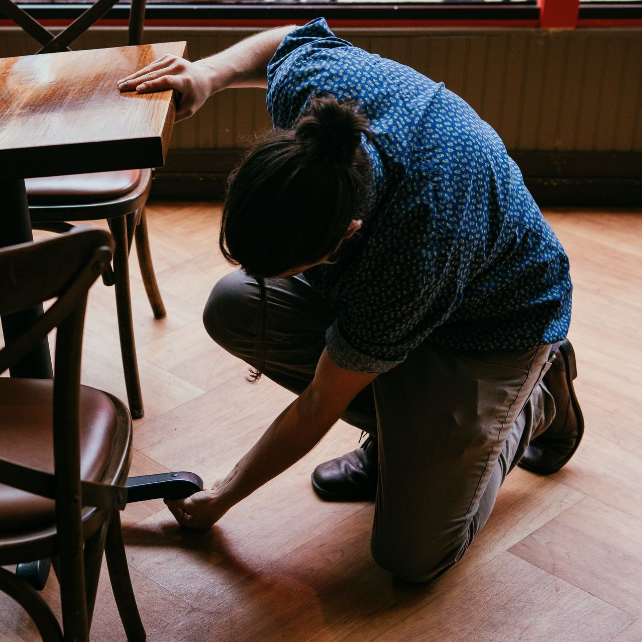

Getting ready to open for the night at Oloroso, one of Mr. Wentz's restaurants. PHOTOS: MICHELLE GUSTAFSON FOR THE WALL STREET JOURNAL(3)
“It weighs on me a lot,” said William Heath, co-founder of Mile High Run Club in New York City. Mr. Heath and his co-founders currently personally guarantee about $1.5 million in obligations for three boutique gyms. The obligations include back rent payments, lease guarantees if the gyms close early and equipment financing.
Mr. Heath hopes to work out an arrangement with his landlords that will allow the gyms to continue to operate, and he plans to open one studio on Monday. “We are not responsible for this,” he said. “It’s not as if we have mismanaged our businesses and just decided to waste the money on something else.”
Landlords often require personal guarantees on commercial leases, said Thomas Lombardi, a real estate litigation attorney with Cozen O’Connor in Los Angeles. They provide some security for landlords and make it harder for businesses to walk away. “There’s a lot more skin in the game,” he said.
Personal guarantees also can make it possible for new and smaller firms to secure financing or a location that might otherwise be out of reach.
“It’s a critical and important tool that shouldn’t go away,” said Steven Hooper Jr., a Seattle restaurant owner who successfully lobbied for a temporary moratorium on the city’s enforcement of personal guarantees. “It provides almost free funding. It provides some security to the landlord without huge security deposits.”
Julia Petiprin said she was nervous about signing a personal guarantee in 2019, but ultimately realized she wouldn’t be able to launch HomeMakers Bar, in Cincinnati, without one.
When the pandemic ended indoor bar service for months, Ms. Petiprin slashed her own salary and survived the winter with a grant from a city development agency. “The stress associated with this is daunting,” said Ms. Petiprin, who said she depleted her savings. “If my business fails, this would put me in debt indefinitely.”
Often, releasing a personal guarantee becomes a point of negotiation between business owners and their creditors. “Banks don’t want to pursue guarantees,” said Alan Thomes, a managing director in charge of SBA lending at Cadence Bank N.A., noting that the process can be costly and messy. “It’s our desire to work it out,” he added. “It just doesn’t always happen.”
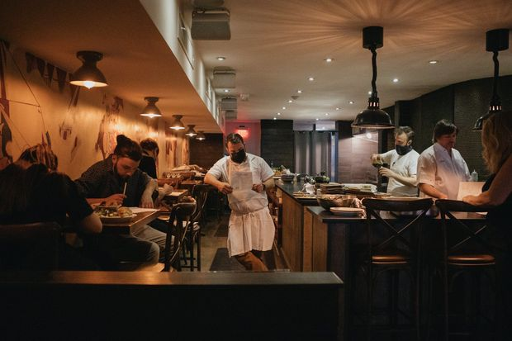

The staff at Oloroso met before reopening last month. A year into the pandemic, owners of small businesses are feeling immense personal financial burden as they try to keep their businesses afloat.
Cadence, a large SBA lender with around $100 million in annual government-backed loans, has negotiated forbearance agreements with the majority of its small-business clients that fell into problems during the pandemic, Mr. Thomes said. Most deferrals extend until the next few months, and many clients will need to start paying back their debts more fully by the summer, he said.
Stuart Gold, a bankruptcy attorney in Southfield, Mich., said he has helped a half-dozen small-business owners unravel personal guarantees in the past year. One client recently paid $65,000, money pulled from a retirement account and borrowed from family and friends, to settle the guarantee on a $270,000 loan backed by the SBA.

SHARE YOUR THOUGHTS
How has your small business or the one you work for been affected by the pandemic? Join the conversation below.
An SBA spokeswoman said the agency requires a guarantee from each owner of 20% or more of the borrowing business. Lenders are “expected to follow prudent lending practices and SBA loan program requirements.” She added that the SBA “is encouraging lenders to work with borrowers who are struggling due to the pandemic.”
Le Nguyen used his house as collateral when he took out a $70,000 loan backed by the SBA to open a nail salon in Ashburn, Va., in 2016. Mr. Nguyen closed the business a year later and fell behind on loan payments in early 2020 after Covid-19 hurt his current venture, a construction business.
Mr. Nguyen said he benefited from six months of debt relief on SBA loan payments during the pandemic, but wasn’t able to arrange a workout with Sonabank, his lender, which recently changed its name to Primis. He said he didn’t read notices sent by his bank because he was busy taking care of his mother, who later died of Covid-19, and he and other family members also became ill.
Days after he buried his mother, someone came to his three-bedroom home and said they had purchased it, Mr. Nguyen said. A notice dated Feb. 15 stated that the home had been sold and that he had five days to vacate the property. Mr. Nguyen’s housing counselor began reaching out to local officials, and Sonabank canceled the foreclosure sale after Mr. Nguyen paid off nearly $38,000 in debt and fees.
Mr. Nguyen, 45, said he knew the personal guarantee could put his home at risk. “You start a business, you are confident you can do it,” he said.
A spokeswoman for Sonabank said, “When dealing with customer relationships, it is our philosophy to try to resolve every situation the best we can so it is in the best interest of the client and the bank.”
For many small-business owners, a final reckoning is being delayed by forbearance agreements, backlogged courts and uncertainty about the future. One challenge is determining the worth of real estate or other personal assets during a pandemic, said Rick Caro, president of Management Vision Inc., a consulting firm for fitness clubs. “Neither side has a good answer now. We are all in flux.”
The playbook is particularly murky for real estate, where practices vary from landlord to landlord.
Madelyn Alfano of Los Angeles permanently closed two of her 10 Maria’s Italian Kitchen locations last year. One landlord released her from a personal guarantee on a $120,000-a-year lease that ran for five more years. In exchange, the landlord took possession of nearly $435,000 in leasehold improvements and received $65,000 in cash. Ms. Alfano kept the liquor license, which she sold for $30,000.
Ms. Alfano was also a partner in a barbecue restaurant that she no longer owns, but whose lease she and her ex-partner personally guaranteed. That landlord rejected an offer to hand over a liquor license, valued at $95,000, and about $550,000 in leasehold improvements in exchange for releasing the pair from a $20,000-a-month lease that extends to 2024, she said. She now sublets the space to her former business partner, but continues to cover a portion of the rent. She is paying a $45,000 stipulated judgment because the subtenant fell behind and the landlord went to court to collect the unpaid rent.
Because of the personal guarantee, Ms. Alfano said she and her ex-partner are on the hook for more than $750,000 under the current arrangement. “It is really disheartening,” she said.
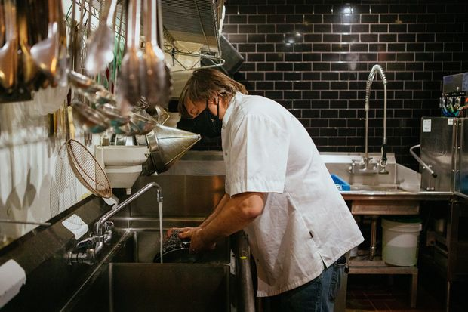

Mr. Wentz, the chef and owner, pitches in washing dishes at his restaurant as he seeks to bring the staff back.
The New York City Council has barred landlords from enforcing personal guarantees on defaults by restaurants, bars and certain other establishments through June 30 due to Covid-related restrictions. Landlords have appealed a decision by a U.S. District Court judge in Manhattan that upheld the law.
The law retroactively strips landlords “of their primary security and contractual remedy in the event of a default,” opponents of the law said in a February court filing in the case, now before the Second U.S. Circuit Court of Appeals in New York.
Gabriel Stulman, owner of eight Manhattan restaurants and a bar before the pandemic, who pushed for the relief, said he was able to settle his disputes with his landlords, but the moratorium didn’t erase back rent. About 75 employees now work at his three operating restaurants, down from 250 before the pandemic.
“I’m fully aware of what we’ve lost,” Mr. Stulman said. “But I have a roof over my head and I’m grateful for it.”
Annelise Lonidier, a yoga-studio operator in Atlanta, had personally guaranteed two years of lease payments totaling more than $100,000 on one of her two locations. She shut down one studio last summer and her landlord eventually released her from the guarantee. In exchange, she paid two of five months of back rent she owed and surrendered the computers, sound system and other contents of the studio.
Ms. Lonidier now offers yoga classes online and still operates one Sacred Thread Yoga studio. She sold the home she bought eight years ago and then purchased a smaller house outside the city, reducing her mortgage payment by half. “I don’t think I would have been able to make it without that,” she said.
Evan Ursitti opened the Verona, a live-music venue in New Port Richey, Fla., in 2018, using $12,000 of his own savings and $12,000 raised from local supporters.
After the pandemic hit, Mr. Ursitti drained his savings, sold off 11 of his 12 motorcycles and took a part-time job at a sign shop. He said he paid nearly all of his bills, but couldn’t cover the Verona’s $2,650 monthly rent.
The Verona’s landlord began eviction proceedings this year after Mr. Ursitti turned down an offer to catch up on six months of unpaid rent by adding $1,000 to his monthly payments and extending the lease by a year, he said. Even after reopening, the Verona’s revenue remains 40% below pre-pandemic levels, he said.
Mr. Ursitti hopes to pull through with the help of a government aid program for live venues and a GoFundMe campaign, but he worries that his personal guarantee could make him responsible for $23,000 in missed rent.
“That’s something I think about every day when I wake up,” he said. “It’s a very scary thing.”
Write to Ruth Simon at ruth.simon@wsj.com and Heather Haddon at heather.haddon@wsj.com

