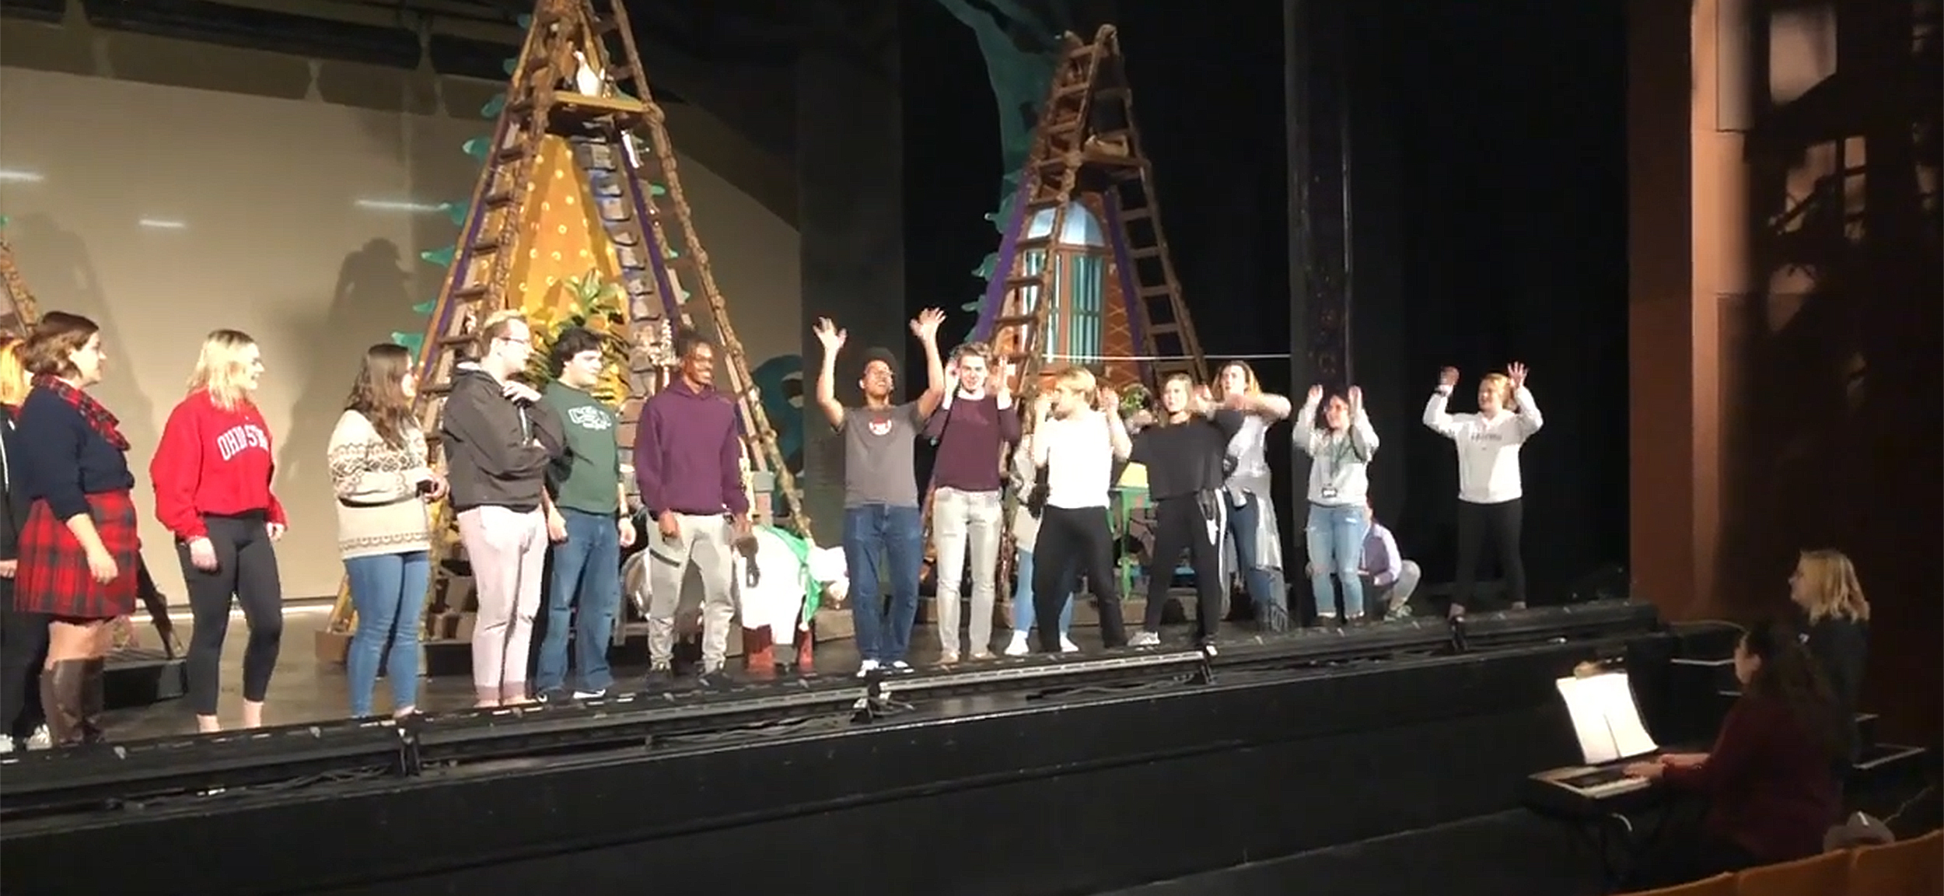

Fall 2019 - Introduction to Theater - Learning Resources

Fall 2019 - Introduction to Theater - Learning Resources

Theater Students, Lisa Bernd, and Heather Caprette

Fall 2019 - Introduction to Theater - Learning Resources by Theater Students, Lisa Bernd Ph.D., Heather Caprette, M.F.A. is licensed under a Creative Commons Attribution-NonCommercial-ShareAlike 4.0 International License, except where otherwise noted.
Please check individual H5P learning objects to see if the author has selected a different license.

Contents
- Introduction
- Chapter 1.1 - Origins of Theater
- Chapter 1.2 Interactive Learning Content: Theatrical Roles
- Chapter 1.3 Interactive Learning Content: Acting
- Chapter 1.4 Interactive Learning Content: Costume Design
- Chapter 1.5 Interactive Learning Content: Directing
- Chapter 1.6 Interactive Learning Content: Lighting Design
- Chapter 1.7 Interactive Learning Content: Set Design & Theaters
- Into the Woods: Theater Development
By: Julia King, Katelyn Zeitz, Kierstan ConwayAll Rights Reserved
- Creative Commons Licenses

Welcome to our Fall 2019 – Introduction to Theater – Learning Resources book. The purpose of this book is to provide open educational resources for those who study Theater. It’s being authored by many helpful Cleveland State University Theater students, as well as Lisa Bernd, PhD, and Heather Caprette, MFA. In the spirit of open, it’s our desire that any alterations of the assignments be shared openly with others, at no charge, but realize we can’t control for this and there’s not always an easy way for someone to share publicly. Many authors of OER generate resources to freely help students and teachers because they realize the challenges students are facing with affording an education and educational materials. We realize this challenge and it’s our desire that these resources be provided for free.
In the sections of Chapter 1, we’ve included interactive learning content to test your knowledge over Theater history and production, with many knowledge checks over Theatrical Worlds, Edited by Charles Mitchell, as well as Playhouse Square theaters and productions, and other theater content. This content can be used by Theater students anywhere in the world, but will be helpful to those reading Theatrical Worlds.
We are using H5p.org interactive content tools at https://h5p.org/content-types-and-applications, installed within Pressbooks hosted on our library systems, to create content for the Interactive Learning Content chapters.
Pressbooks is a free open source download from Github (See: https://github.com/pressbooks/pressbooks). This version allows install of plug-ins such as h5p. Anyone can register for an account on Pressbooks.com for free, if they would like Pressbooks to host their book.

Chapter 1

Chapter 1.1 - Origins of Theater
Below are student created H5P learning objects and knowledge checks on the origins of theater.
An interactive or media element has been excluded from this version of the text. You can view it online here:
https://pressbooks.ulib.csuohio.edu/theater-fall-2019/?p=5
By Najee Muhammad
An interactive or media element has been excluded from this version of the text. You can view it online here:
https://pressbooks.ulib.csuohio.edu/theater-fall-2019/?p=5
by Jasmine Hayes, 2019
An interactive or media element has been excluded from this version of the text. You can view it online here:
https://pressbooks.ulib.csuohio.edu/theater-fall-2019/?p=5
by Jasmine Hayes, 2019
An interactive or media element has been excluded from this version of the text. You can view it online here:
https://pressbooks.ulib.csuohio.edu/theater-fall-2019/?p=5
by Jasmine Hayes, 2019
An interactive or media element has been excluded from this version of the text. You can view it online here:
https://pressbooks.ulib.csuohio.edu/theater-fall-2019/?p=5
by Jasmine Hayes, 2019
An interactive or media element has been excluded from this version of the text. You can view it online here:
https://pressbooks.ulib.csuohio.edu/theater-fall-2019/?p=5
by Jasmine Hayes, 2019
An interactive or media element has been excluded from this version of the text. You can view it online here:
https://pressbooks.ulib.csuohio.edu/theater-fall-2019/?p=5
by Shawnlee Abri, 2019

Chapter 2

Chapter 1.2 Interactive Learning Content: Theatrical Roles
An interactive or media element has been excluded from this version of the text. You can view it online here:
https://pressbooks.ulib.csuohio.edu/theater-fall-2019/?p=37
by Alaina Wiseman, 2019
An interactive or media element has been excluded from this version of the text. You can view it online here:
https://pressbooks.ulib.csuohio.edu/theater-fall-2019/?p=37
by Allyson Godinsky, 2019
An interactive or media element has been excluded from this version of the text. You can view it online here:
https://pressbooks.ulib.csuohio.edu/theater-fall-2019/?p=37
by Max Torres, 2019
An interactive or media element has been excluded from this version of the text. You can view it online here:
https://pressbooks.ulib.csuohio.edu/theater-fall-2019/?p=37
Stage Management, by Annemarie Lieb, 2019
An interactive or media element has been excluded from this version of the text. You can view it online here:
https://pressbooks.ulib.csuohio.edu/theater-fall-2019/?p=37
by Allyson Godinsky, 2019

Chapter 3

Chapter 1.3 Interactive Learning Content: Acting
An interactive or media element has been excluded from this version of the text. You can view it online here:
https://pressbooks.ulib.csuohio.edu/theater-fall-2019/?p=39
Timeline by Mason Repas, 2019
An interactive or media element has been excluded from this version of the text. You can view it online here:
https://pressbooks.ulib.csuohio.edu/theater-fall-2019/?p=39
Question Set by Olivia Broughton, 2019
An interactive or media element has been excluded from this version of the text. You can view it online here:
https://pressbooks.ulib.csuohio.edu/theater-fall-2019/?p=39
Multiple Choice by Allyson Godinsky, 2019
An interactive or media element has been excluded from this version of the text. You can view it online here:
https://pressbooks.ulib.csuohio.edu/theater-fall-2019/?p=39
What is Acting by Everett Walker, 2019
An interactive or media element has been excluded from this version of the text. You can view it online here:
https://pressbooks.ulib.csuohio.edu/theater-fall-2019/?p=39
by Mohamed Zeyad, 2019
An interactive or media element has been excluded from this version of the text. You can view it online here:
https://pressbooks.ulib.csuohio.edu/theater-fall-2019/?p=39
by Mohamed Zeyad, 2019
An interactive or media element has been excluded from this version of the text. You can view it online here:
https://pressbooks.ulib.csuohio.edu/theater-fall-2019/?p=39
by Mohamed Zeyad, 2019
An interactive or media element has been excluded from this version of the text. You can view it online here:
https://pressbooks.ulib.csuohio.edu/theater-fall-2019/?p=39
by Allyson Godinsky, 2019

Chapter 4

Chapter 1.4 Interactive Learning Content: Costume Design
Transformation into Costume I by Katie Lytle, 2019
An interactive or media element has been excluded from this version of the text. You can view it online here:
https://pressbooks.ulib.csuohio.edu/theater-fall-2019/?p=41
Transformation into Costume II by Katie Lytle, 2019
An interactive or media element has been excluded from this version of the text. You can view it online here:
https://pressbooks.ulib.csuohio.edu/theater-fall-2019/?p=41
An interactive or media element has been excluded from this version of the text. You can view it online here:
https://pressbooks.ulib.csuohio.edu/theater-fall-2019/?p=41
H5P Question Set by Angel Ciccarelli, 2019
An interactive or media element has been excluded from this version of the text. You can view it online here:
https://pressbooks.ulib.csuohio.edu/theater-fall-2019/?p=41
by Shania Jones, 2019
An interactive or media element has been excluded from this version of the text. You can view it online here:
https://pressbooks.ulib.csuohio.edu/theater-fall-2019/?p=41
by Shania Jones, 2019
An interactive or media element has been excluded from this version of the text. You can view it online here:
https://pressbooks.ulib.csuohio.edu/theater-fall-2019/?p=41
by Shania Jones, 2019
An interactive or media element has been excluded from this version of the text. You can view it online here:
https://pressbooks.ulib.csuohio.edu/theater-fall-2019/?p=41
by Shania Jones, 2019
An interactive or media element has been excluded from this version of the text. You can view it online here:
https://pressbooks.ulib.csuohio.edu/theater-fall-2019/?p=41
by Shania Jones, 2019
An interactive or media element has been excluded from this version of the text. You can view it online here:
https://pressbooks.ulib.csuohio.edu/theater-fall-2019/?p=41
By: Jordan Kopf, Jenna Gallion, and Guy Coleman, 2019

Chapter 5

Chapter 1.5 Interactive Learning Content: Directing
An interactive or media element has been excluded from this version of the text. You can view it online here:
https://pressbooks.ulib.csuohio.edu/theater-fall-2019/?p=43
by Allyson Godinsky, 2019

Chapter 6

Chapter 1.6 Interactive Learning Content: Lighting Design
An interactive or media element has been excluded from this version of the text. You can view it online here:
https://pressbooks.ulib.csuohio.edu/theater-fall-2019/?p=46
Course Presentation by Kaitlyn Jozwiak, 2019
An interactive or media element has been excluded from this version of the text. You can view it online here:
https://pressbooks.ulib.csuohio.edu/theater-fall-2019/?p=46
by Shawnlee Abri, 2019
An interactive or media element has been excluded from this version of the text. You can view it online here:
https://pressbooks.ulib.csuohio.edu/theater-fall-2019/?p=46
by Caleb Grant, 2019
An interactive or media element has been excluded from this version of the text. You can view it online here:
https://pressbooks.ulib.csuohio.edu/theater-fall-2019/?p=46
by Shawnlee Abri, 2019
An interactive or media element has been excluded from this version of the text. You can view it online here:
https://pressbooks.ulib.csuohio.edu/theater-fall-2019/?p=46
Question Set by Rachel Miller, 2019

Chapter 7

Chapter 1.7 Interactive Learning Content: Set Design & Theaters
An interactive or media element has been excluded from this version of the text. You can view it online here:
https://pressbooks.ulib.csuohio.edu/theater-fall-2019/?p=34
Virtual Tour of Connor Palace Theater with Interactive Hot Spots. Heather Caprette, 2017 and 2019. CC-BY-NC-SA.
An interactive or media element has been excluded from this version of the text. You can view it online here:
https://pressbooks.ulib.csuohio.edu/theater-fall-2019/?p=34
Parts of a Theatre by Mekenzie Keogh, Zander Saunders, Ollie Tracy, 2019
An interactive or media element has been excluded from this version of the text. You can view it online here:
https://pressbooks.ulib.csuohio.edu/theater-fall-2019/?p=34
by Allyson Godinsky, 2019

Chapter 8

Into the Woods: Theater Development

By: Julia King, Katelyn Zeitz, Kierstan Conway
An interactive or media element has been excluded from this version of the text. You can view it online here:
https://pressbooks.ulib.csuohio.edu/theater-fall-2019/?p=63
Into the Woods production questions (Course Presentation H5P) by Katelyn Zeitz, 2019
An interactive or media element has been excluded from this version of the text. You can view it online here:
https://pressbooks.ulib.csuohio.edu/theater-fall-2019/?p=63
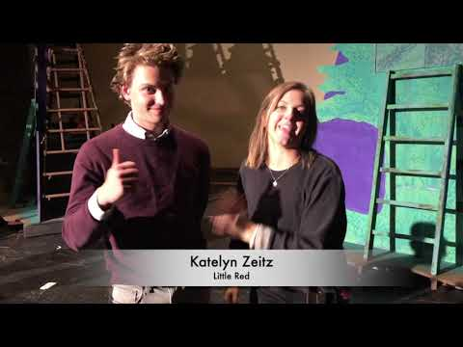
A YouTube element has been excluded from this version of the text. You can view it online here: https://pressbooks.ulib.csuohio.edu/theater-fall-2019/?p=63
An interactive or media element has been excluded from this version of the text. You can view it online here:
https://pressbooks.ulib.csuohio.edu/theater-fall-2019/?p=63
Making a Musical – Into the Woods, A production of CSU Theatre & Dance
An interactive or media element has been excluded from this version of the text. You can view it online here:
https://pressbooks.ulib.csuohio.edu/theater-fall-2019/?p=63
Find the Words by Julia King, 2019

1

Creative Commons Licenses
Creative Commons is a non-profit organization dedicated to the sharing and access of knowledge. They’ve developed 6 copyright licenses to make it easy to assign certain permissions to a work which an author would like to share with the public. All licenses require attribution (BY) to the creator of the material when it is used or shared. The CC-BY attribution is combined with other licensing elements, such as NonCommercial (NC), NoDerivatives (ND), and ShareAlike (SA). The Creative Commons explanation of their licenses exists on their website (visit https://creativecommons.org/licenses/ ). Creative Commons (CC) licenses wouldn’t be applied to work that is in the public domain. Below is an explanation of the Creative Commons licenses with the least restrictive ones listed first. The following explanations were taken from A Guide to Making Open Textbooks with Students, published by the Rebus Community, and authored by Zoe Wake Hyde (CC-BY). The license symbols are below each explanation.

CC-BY: Attribution
Anyone is free to share & adapt the work, as long as they give appropriate credit, provide a link to the license and indicate if changes were made to the original material.

CC-BY-SA: Attribution-Share Alike
Anyone is free to share & adapt the work, as long as they give appropriate credit, provide a link to the license, and indicate if changes were made to the original material. Any derivative works must share the same license as the original material. This means that if someone remixes your work, or makes a new project that uses your work, they must also license that work under a CC-BY-SA license.


CC-BY-NC: Attribution-Non Commercial
Anyone is free to share & adapt the work for any non-commercial use, as long as they give appropriate credit, provide a link to the license and indicate if changes were made to the original material.


CC-BY-ND: Attribution-No Derivatives
Anyone is free toshare the work, as long as they give appropriate credit, provide a link to the license and indicate if changes were made to the original material. Any derivative works may not be distributed. This means that you can make a remix or new project that makes use of the original work for private use, but cannot share or publish your derivative work.


CC-BY-NC-SA: Attribution-Non Commercial-Share Alike
Anyone is free to share & adapt the work for any non-commercial use, as long as they give appropriate credit, provide a link to the license, and indicate if changes were made to the original material. Any derivative works must share the same license as the original material.


CC-BY-NC-ND: Attribution-Non Commerical-No Derivatives
Anyone is free to share the work for any non commercial use, as long as they give appropriate credit, provide a link to the license, and indicate if changes were made to the original material. Any derivative works may not be distributed.

The Creative Commons licenses work with other platforms, such as flickr, Wikipedia, Youtube, Vimeo, Wikimedia Commons, and MIT Open Courseware. They have a CC license generator that asks you a few questions about how you would or would not like to share your work (visit https://creativecommons.org/choose/). After answering, the page generates HTML that you can embed on your website that creates the license symbol and the link to the explanation of the license. An example of what this looks like is below:
This work is licensed under a Creative Commons Attribution-NonCommercial-ShareAlike 4.0 International License.

